LAB TASK - 5
Name: A. Yamini
Roll no: AP24135010016
PhD Scholar

5. Implementation of Diffie-Hellman algorithm
Aim: To demonstrate the Diffie–Hellman key exchange protocol and compute a shared secret key between two parties securely.
Procedure:
- Choose a prime number p and a generator g as public parameters.
- Both parties select private keys, compute their public keys, and exchange them.
- Each computes the shared secret using the other’s public key; success is verified if both keys match.

CODE:
# Diffie–Hellman Key Exchange

def diffie_hellman():
# Step 1: Publicly known values (prime number p and base g)
p = 23 # Prime number
g = 5 # Generator (primitive root of p)
print("Publicly shared values:\nPrime (p):", p, "\nBase (g):", g)

# Step 2: Alice chooses her private key
a = 6 # Private key (kept secret)
A = pow(g, a, p) # Compute public key (g^a mod p)
print("\nAlice's private key:", a)
print("Alice's public key (A):", A)

# Step 3: Bob chooses his private key
b = 15 # Private key (kept secret)
B = pow(g, b, p) # Compute public key (g^b mod p)
print("\nBob's private key:", b)
print("Bob's public key (B):", B)

# Step 4: Exchange public keys and compute the shared secret
shared_key_alice = pow(B, a, p) # (B^a mod p)
shared_key_bob = pow(A, b, p) # (A^b mod p)

# Step 5: Both shared keys should match
print("\nShared key computed by Alice:", shared_key_alice)
print("Shared key computed by Bob: ", shared_key_bob)

if shared_key_alice == shared_key_bob:
print("\n Key Exchange Successful! Shared Secret Key:", shared_key_alice)
else:
print("\n Key Exchange Failed!")

# Run the program
diffie_hellman()

OUTPUT:

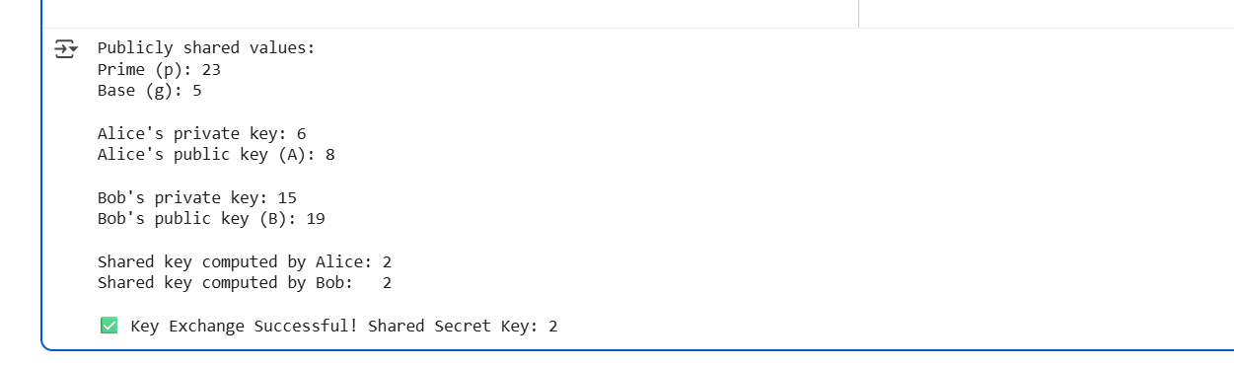
GITHUB LINK:

